**WNR STANDARDS & REGULATIONS**

**Overview:**

The purpose of this document is to list out the protocol standards and government regulations that WNR must take into consideration during the project. The document first discusses the government regulations that pertain to the project, and then goes into details about the technical standards that may apply.

**Government Regulations:**

1. FDA - Food & Drug Administration[1]



FDA is a federal agency of the United States Department of Health and Human Services. It is responsible for protecting and promoting public health through multiple aspects of daily life, one of which is medical devices. The Center for Devices and Radiological Health (CDRH) branch of FDA is responsible for the premarket approval of all medical devices, as well as overseeing the manufacturing, performance, and safety of these devices.

There are two different types of requests submission for FDA regulation: “FDA-Cleared” and “FDA-Approved”. Since there are already existing similar products on the market, the WNR device falls in the category of “FDA-Cleared”, means it needs to be proved as “substantially equivalent” to the predicate devices already on the market. The electrode and microprocessor, especially the Intan chip front end are mature products from market, so proving this component will not be an issue. Another component of the system is the wireless transmission system installed on the device, which needs to demonstrate “safety and efficacy”. The Bluetooth Low Energy® protocol used on the transmission module fits IEEE-802.15.1 standard, which also has been proven to be harmless to people, given the vast number of products that exist on the consumer. Since the wireless neural recorder this project aims to create uses the functionality of two existing products on the market that has been FDA approved, it should not be difficult to secure approval for the entire system.

1. FCC - Federal Communications Commission[2]

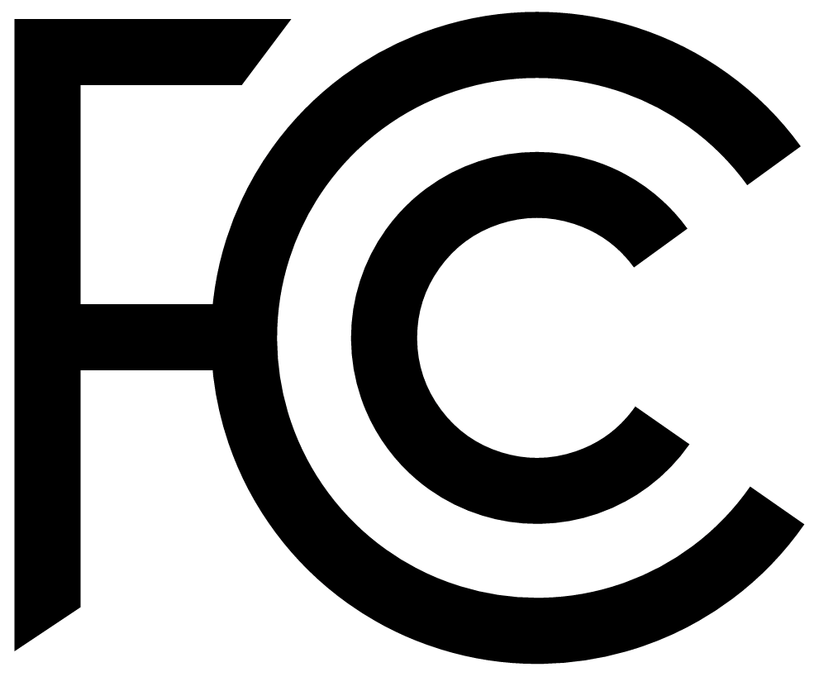 

The Federal Communications Commission is an agency that regulates interstate communications. One important related function is the control of radio frequency bandwidth. Since the WNR device involves wireless communication, it falls under FCC’s concern. The Bluetooth Low Energy protocol, IEEE-802.15.1, used in this process specifically needs a Bluetooth Compliance and Certification clearance from the FCC. The market release of this project’s wireless neural recorder product requires both qualification and certification from the FCC as well. The BLE module that will be used for wireless transmission is a component made from Texas Instruments. Very little deviation from the device will be necessary to create a communication network for wireless neural transmission, so seeking FCC qualification when incorporating an already qualified device from the market should be straightforward.

For the FCC certification, the team will directly apply to the FCC. The application process requires a preparation of materials: cover letter, test report from lab experiments, user's manual, schematics with parts list, block diagram, a photo of the test setup, internal/external photos, and the system’s operational description.

3. HIPAA - Health Insurance Portability and Accountability Act[3]



WNR device is mainly related with Title II of HIPAA (Administrative Simplification provisions), which standardizes electronic healthcare transactions. Because the WNR device does not involve medical information transaction, the main concern for the project is the Privacy Rule that regulates the use and disclosure of Protected Health Information held by health institutes or personnels. The information gathered from WNR device is considered private and should not be disclosed to third parties without permission. To address this concern, the wireless transmission channel should be encrypted and no data is stored in on-board memory. Since the product is still under development and testing, the encryption method will be discussed in detail after a more sophisticated prototype is produced.

**Engineering Standards and Protocols:**

1. I2C (Inter-Integrated Circuit)[4]

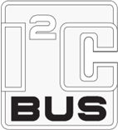

Invented by Philips Semiconductor (Now NXP Semiconductor), I2C bus protocol is a multi-master, multi-slave, single-ended serial computer bus that is widely used in microprocessor applications. It is still maintained by NXP Semiconductor and the most recent standard announced was on 4th, April 2014. The I2C protocol is written interchangeably as I2C or IIC. For a large array of sensors like accelerometer and temperature sensors that could be incorporated in WNR project, I2C bus is used as the means for communication. Although the protocol is still maintained by a company, I2C protocol is free since October 10, 2006. Fees are still required to obtain I2C slave addresses allocated by NXP although such cost will be contained in the price of the components that uses I2C. The main advantage of I2C is that it only requires 2 lines and they are bidirectional data lines. However I2C is more complex to set-up, but once stable it can be easily extended to additional applications as long as your bus wiring doesn't get too long or large.

1. SPI (Serial Peripheral Interface)[7]

SPI, invented by Motorola, is a single-master, multiple-slave, four-wire serial bus communication protocol that is widely used to communicate data between one master and multiple users. The protocol aims to provide data communication between devices, just like I2C. SPI is a synchronous serial transmission scheme that requires four wires to connect the master to each slave. One line is the clock line, which synchronizes the rate at which data is sent and received between the master and slave. There are two data lines connecting the slave and master; one line is used by the slave to transmit data to the master and the other line is used by the master to transmit data to the slave. The fourth line is the slave select line. The master uses this line to select which slave it will communicate with. SPI has no default standard. As such, there are many different variations of the protocol, as entities create their own versions. There are no fees associated with SPI. For this project, SPI is a probable and viable method, that is simpler to use that I2C, for transmitting data between different components of the overall system. We will be using SPI as it is faster and easier to set-up than I2C. With our A2D, microprocessor components, and wireless transmission components, SPI seems to be the fastest and easiest way to implement our system.

1. Transmission Control Protocol (TCP)

For introduced by Vint Cerf and Bob Kahn in an Institute of Electrical and Electronic Engineers (IEEE) paper[5], the Transmission Control Protocol (TCP) has become a core protocol of the internet protocol suite where it works in complement with the Internet Protocol (IP). Together, these two protocols form the foundations for the TCP/IP construct of current internet standards. TCP is a communication protocol with high reliability and error-checking capabilities - characteristics required for the wireless communication portion of the project. As such, TCP could potentially serve as a viable communication scheme used to encode electrode signals to be sent wirelessly.

1. TIA(Telecommunications Industry Association)/EIA RS-232

First developed in 1969 by Telecommunications Industry Association[6], the RS-232 is a protocol that is used for serial communication in devices such as modems. For microprocessor applications, RS-232 is largely used for UART communication through USB cables. This allows developers of microprocessor applications to send data through USB connection to a terminal, like a computer, and read the signal from terminal serial port. Such protocol and the aforementioned usage greatly aids debugging when dealing with data-intensive applications, such as the WNR project. Nevertheless, RS-232 is a wired connection protocol and will therefore only be used for debugging purposes for our project. Actual data transmission will still make use of wireless protocols like TCP.

1. Bluetooth v4.1 Low Energy(BLE)[8]

Developed by BlueTooth, Bluetooth Low Energy is a wireless communication standard that enables reliable, low energy, short distance wireless communication. BLE operates on the 2.4 GHz spectrum. It uses Gaussian Frequency Shift-keying (GFSK) modulation at 1Mb/s. BLE supports both broadcasting radio signal from a signal transmitter as well as one-to-one communication between a transmitter and a receiver. Since the WNR project focuses on incorporating wireless communication on small medical electrodes, BLE serves as an ideal protocol that provides wireless capabilities at a very low energy cost but it lacks the throughput necessary for our data transmission needs at this time. However it is the most low power and secure option that we hope to be able to use in the future.

6. Bluetooth Classic v2.1 Basic Rate / Enhanced Data Rate (BR/EDR)[9]

Bluetooth Core Specification Version 2.1, referred to as Basic Rate/Enhanced Data Rate (BR/EDR), made it easier for consumers to connect Bluetooth devices. The Bluetooth RF (physical layer) operates in the unlicensed ISM band at 2.4GHz. The system employs a frequency-hop transceiver to combat interference and fading, and provides many FHSS carriers. Basic Rate supports a bit rate of 1 Mbps while Enhanced Data Rate supports a gross air bit rate of 2Mb/s. While Bluetooth EDR supports our data transmission needs, it does use more power than Bluetooth Low Energy but that is a tradeoff we will have to deal with right now.

**References:**

[1] "Medical Devices." *U.S. Food and Drug Administration*. U.S. Food and Drug Administration. Web. 23 Oct. 2015.

[2] "FCC." *FCC*. Web. 23 Oct. 2015.

[3] "Health Information Privacy." *HHS*. Web. 23 Oct. 2015.

[4] "UM10204: I2C-bus Specification and User Manual." NXP Semiconductors, 4 Apr. 2014. Web. 23 Oct. 2015.

[5] Cerf, V., and R. Kahn. "A Protocol for Packet Network Intercommunication." *IEEE Transactions on Communications IEEE Trans. Commun.*: 637-48. Print.

[6] Mcghee, Joseph. "RS 232 and EIA/TIA 232 Serial Interface." *Handbook of Measuring System Design* (2005). Print.

[7] "SPI Implementation in IQRF for (DC)TR-7xD Technical Guide." IQRF. Web.

[8] "Bluetooth Smart (Low Energy) Technology." *Bluetooth Development Portal*. Bluetooth. Web. 23 Oct. 2015.

[9] “Basic Rate/Enhanced Data Rate (BR/EDR).” *Bluetooth Technology Basics.* Bluetooth.

Web. 13 Dec. 2015.